EV Charging Site
Creating reports to show the status on Walmart EV Charging Site.
Source: Live connection from the Teams excel sheet.
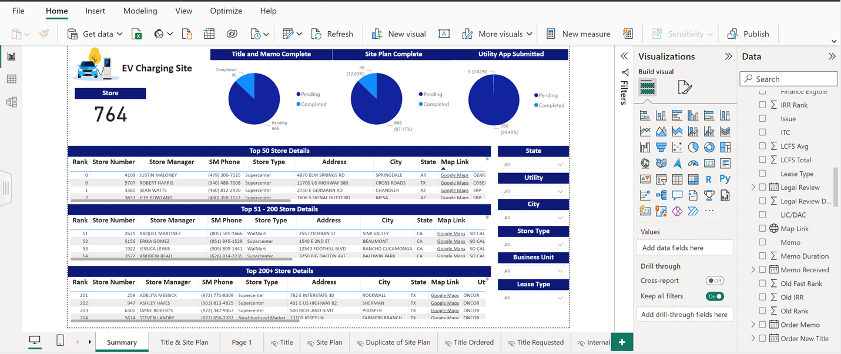

- Showing results for the stores which contains rank.
- 3 Tables shows the information about the stores ranks from 0-50, 51-200 & 201+.
- 3 categories of pie chart shows the completion information of the Title and Memo status, Site Plan Complete and Utility App information.
- All these data can be filtered by State, Utility, City, Store Type, Business Unit and Lease Type.
- Tables include Store Manager name and Store Manager Phone number as well.
- Map link column will redirect to the google map location where the store is located in the new web page. This is achieved by considering Latitude and Longitude from the site plan sheet.
- These tables contains the information of the Store details and store status as well.
- 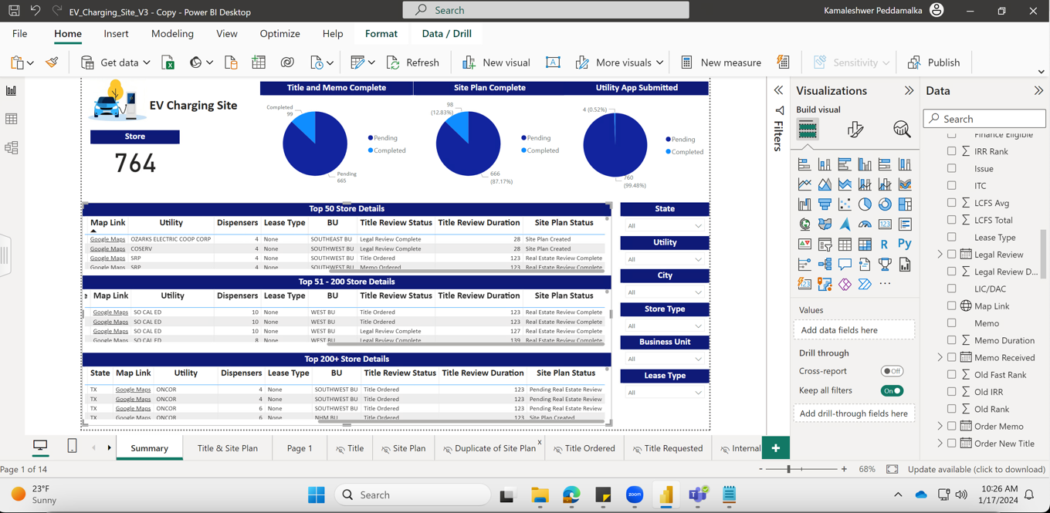
Title & Site Plan:
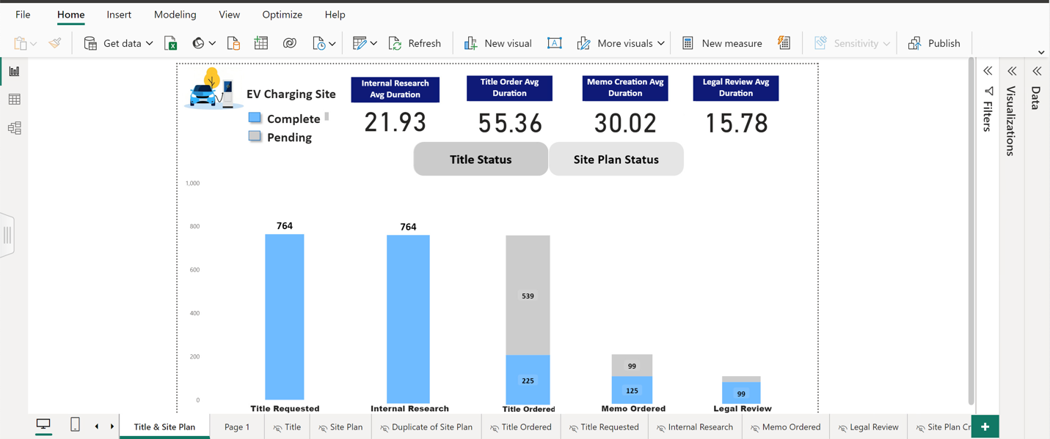
- This page gives the information about Title Status and Site Plan Status information with drill through option to each category.
- On Title Status it will give information about the Title Requested, Internal Research, Title Ordered, Memo Ordered and Legal Review completed or pending status.
- Legal review is the final stage on the Title Status.
- All these bars can drill through to table information about the pending and completed status.
- On the top of bar cards will display the avg duration for each category. It is calculated based on the start and end date of each category.

Below is the drill through table for all categories:

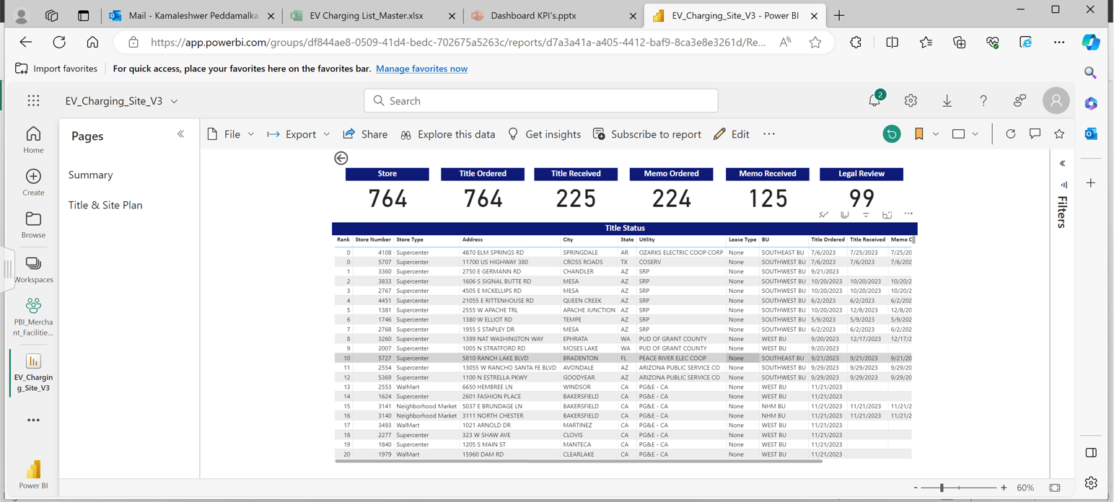

Site Plan Status:

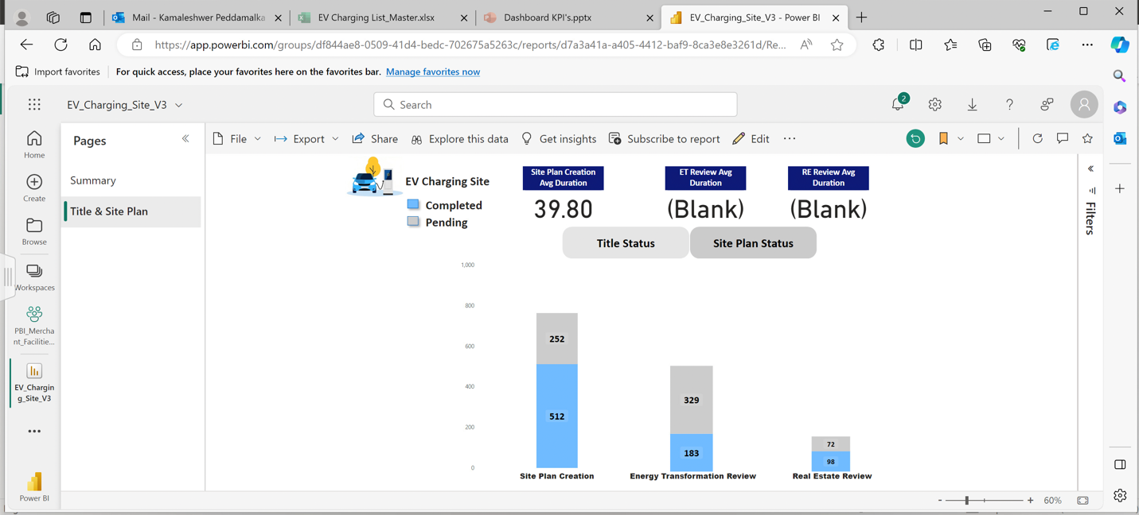

- This is the last stage on the EV Charging site setup.
- On Site Plan Status it will give information about the Site Plan Creation, Energy Transformation Review and Real Estate Review completed and pending status.
- Real Estate Review will be the final stage for the EV Charging site setup.
- On the top of bar cards will display the avg duration for each category. It is calculated based on the start and end date of each category.
- All these bars can drill through to table information about the pending and completed status.

Below is the drill through table for all categories:

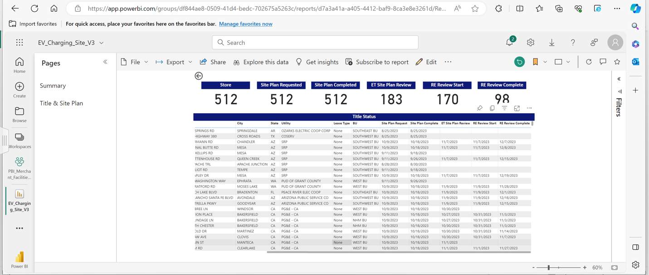
Creating one more page for the map to show all the store points and status of those.

